Questions 1 - 10

Questions 1 – 6
Choose the correct letter A, B or C.
1.The 'Family Welcome' event in the art gallery begins at
A.10 am.B.10.30 am.C.2 pm.
2.The film that is now shown in the 'Family Welcome' event is about
A.sculpture.B.painting.C.ceramics.
3.When do most of the free concerts take place?
A.in the morning.B.at lunchtime.C.in the evening.
4.Where will the 4 pm concert of Latin American music take place?
A.in a museum.B.in a theatre.C.in a library.
5.The boat race begins at
A.Summer Pool.B.Charlesworth Bridge.C.Offord Marina.
6.One of the boat race teams
A.won a regional competition earlier this year.B.has represented the region in a national competition.C.has won several regional competitions.

Questions 7 – 10
Complete the sentences below. Write ONE WORD ONLY for each answer.
Paxton Nature Reserve
•Paxton is a good place for seeing rare [7] all year round.
•This is a particularly good time for seeing certain unusual [8].
•Visitors will be able to learn about [9] and then collect some.
•Part of the [10] has been made suitable for swimming.

Questions 11 - 20

Questions 11 – 15
Choose the correct letter A, B or C.
11.In Shona's opinion, why do fewer people use buses in Barford these days?
A.The buses are old and uncomfortable.B.Fares have gone up too much.C.There are not so many bus routes.
12.What change in the road network is known to have benefited the town most?
A.the construction of a bypass.B.the development of cycle paths.C.the banning of cars from certain streets.
13.What is the problem affecting shopping in the town centre?
A.lack of parking spaces.B.lack of major retailers.C.lack of restaurants and cafés.
14.What does Shona say about medical facilities in Barford?
A.There is no hospital.B.New medical practices are planned.C.The number of dentists is too low.
15.The largest number of people are employed in
A.manufacturing.B.services.C.education.

Questions 16 – 20

PLANS FOR FACILITIES
What is planned for each of the following facilities? Choose FIVE answers from the box and write the correct letter A–G next to questions 16–20.
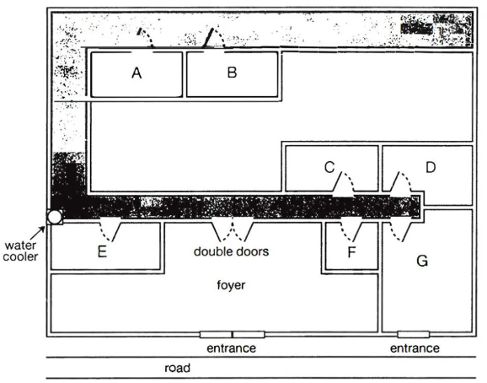

A It will move to a new location. B It will have its opening hours extended. C It will be refurbished. D It will be used for a different purpose. E It will have its opening hours reduced. F It will have new management. G It will be expanded.
16.railway station car park
17.cinema
18.indoor market
19.library
20.nature reserve

Questions 21 - 30

Questions 21 – 26
Complete the table below. Write ONE WORD ONLY for each answer.
Subject of drawing | Change to be made
A [21] surrounded by trees | Add Malcolm and a [22] noticing him
People who are [23] outside the forest | Add Malcolm sitting on a tree trunk and [24]
Ice-skaters on [25] covered with ice | Add a [26] for each person

Questions 27 – 30

REPORT PARTS
Who is going to write each of the following parts of the report? Write the correct letter A–D next to questions 27–30.
A Helen only B Jeremy only C both Helen and Jeremy D neither Helen nor Jeremy
27.how they planned the project
28.how they had ideas for their stories
29.an interpretation of their stories
30.comments on the illustrations

Questions 31 - 40
Complete the notes below. Write ONE WORD ONLY for each answer.
ETHNOGRAPHY IN BUSINESS
Ethnography: research which explores human cultures
It can be used in business:
● to investigate customer needs and 31
● to help companies develop new designs
Examples of ethnographic research in business
Kitchen equipment
● Researchers found that cooks could not easily see the 32 in measuring cups.
Cell phones
● In Uganda, customers paid to use the cell phones of entrepreneurs.
● These customers wanted to check the 33 used.
Computer companies
•There was a need to develop 34 to improve communication between system administrators and colleagues.
Hospitals
● Nurses needed to access information about 35 in different parts of the hospital.
Airlines
● Respondents recorded information about their 36 while travelling.
Principles of ethnographic research in business
● The researcher does not start off with a hypothesis.
● Participants may be selected by criteria such as age, 37 or product used.
● The participants must feel 38 about taking part in the research.
● There is usually direct 39 of the participants.
● The interview is guided by the participant.
● A lot of time is needed for the 40 of the data.
● Researchers look for a meaningful pattern in the data.

